**Winterbourne Junior Girls’ School**

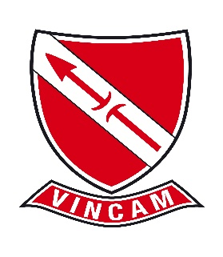

**Vacancy: one to one Teaching Assistants**

**Winterbourne Junior Girls’ School, is seeking two committed and highly motivated one to one Teaching Assistants to join our team in September 2025:**

**Positions Available:**

1. **Full Time, fixed term 27.30 hours per week, term-time only including INSET days**
2. **Part Time, fixed term 16.15 hours per week, term-time only including INSET days**

We are looking to appoint an enthusiastic and motivated one to one teaching assistants who share our vision “Aspirations, Expectations, No Excuses – VINCAM – Together We Conquer” to support our more vulnerable learners in our school.

Visits to Winterbourne Junior Girls’ School are welcome; please contact the school office in the first instance on 020 8684 3532.

Closing date for applications **Friday 4 July 2025 at 3pm** (if you do not hear from us by 3pm on Tuesday 8 July, you have not been shortlisted). Interviews will take place on **Thursday 10** July 2025 (Mathematics and English assessments will be part of the interview process).

Winterbourne Junior Girls’ School is committed to safeguarding and promoting the welfare of children and young people. We are an equal opportunities employer.