**Winterbourne Junior Girls’ School**

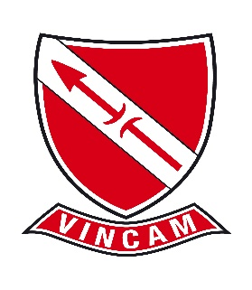

**Winterbourne Junior Girls’ School, is seeking a committed and highly motivated Level one Teaching Assistant to start September 2025 (fixed term, full time 27.5 hours a week, term-time only including INSET)**

We are seeking to appoint an enthusiastic and motivated Teaching Assistant who shares our vision **“Aspirations, Expectations, No Excuses – VINCAM – Together We Conquer”** to raise standards and make a significant contribution to providing the best possible education for children in our school.

Visits to Winterbourne Junior Girls’ School are welcome; please contact the school office in the first instance on 020 8684 3532.

Closing date for applications Friday 4 July 2025 at 3pm (if you have not heard by 3pm on Tuesday 8 July, you have not been shortlisted). Interviews will take place on Thursday 10 July 2025 (Mathematics and English test will be set).

Winterbourne Junior Girls’ School is committed to safeguarding and promoting the welfare of children and young people. We are an equal opportunities employer.