**Winterbourne Junior Girls’ School**

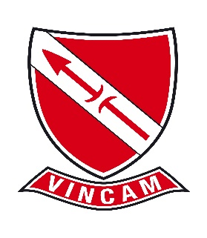

**Winterbourne Junior Girls' School is seeking a committed, highly motivated and keen KS2 teacher to start, September 2025 (Fixed term, full-time)**

If you are an ECT or a more experienced teacher looking for work in a supportive environment in which groups of teachers plan together to produce great lessons for our children, then we'd like to hear from you. If you are just starting your career or are a good teacher looking for a new challenge then we'd like to hear from you.

For a confidential discussion or enquiries about this role, please contact the Head teacher:

Name: Mary Berkeley-Agyepong

Number: 020 8684 3532.

Email: [head@winterbournegirls.croydon.sch.uk](mailto:head@winterbournegirls.croydon.sch.uk)

Closing date for applications: Friday 4 July 2025 2025-noon

Interview date: Thursday 10 July 2025

Winterbourne Junior Girls’ School is committed to safeguarding and promoting the welfare of children and young people. We expect all staff and volunteers to share this commitment, and to embrace our school ethos – Aspirations, Expectations, No Excuses – VINCAM – Together We Conquer. We are an equal opportunities employer.